Technical Proposal & Financial Proposal for BNPL – Mobile App Development (Frontend Only)

1. Introduction
This document presents a technical and financial proposal for building a cross‑platform Buy Now, Pay Later (BNPL) mobile application for iOS and Android. The application will be developed from scratch as a front-end-only delivery and will integrate with existing backend APIs provided by the client or third‑party partners. Designing and UI/UX activities are out of scope; the proposal focuses strictly on implementing the approved UI screens, user flows, and API-driven features.

2. Project Scope Overview
The project will be delivered in a single phase focused on mobile-fronted development. The core objective is to deliver a high‑performance, native‑like BNPL experience with bilingual support (Arabic & English) including LTR/RTL layouts, secure authentication, KYC onboarding, product shopping flows, and loan/order management.
In Scope (Frontend):
- Flutter mobile app development for iOS and Android (single codebase).
- Implementation of UI screens and user journeys based on provided UI references (mobile screens).
- REST API integration with existing backend services (authentication, KYC, products, checkout, loans, orders, profile).
- Localization: Arabic & English, including LTR & RTL layout support and language switching.
- Secure local storage and session management for tokens and user preferences.
- Quality assurance, device testing, and release-ready builds (TestFlight / Play Internal Testing).
Out of Scope:
- Backend/API development or modification (including database, business rules, and server hosting).
- Admin/Merchant portals (web or mobile).
- UI/UX design, branding, illustrations, or design system creation.
- Production published under client accounts (can be supported as guidance; store owner accounts remain client-managed).

3. Proposed Technology Choice – Why Flutter
Flutter is proposed as the primary framework for this startup BNPL app due to the following advantages:
- Consistent UI/UX across iOS and Android with a single rendering engine (pixel‑perfect control).
- High performance for complex UI and animations due to compiled native ARM code and efficient rendering pipeline.
- Strong support for RTL/LTR and localization, suitable for Arabic-first experiences with dynamic layout direction.
- Faster iteration with hot reload and a unified codebase for feature parity, reducing long‑term maintenance overhead.
- Mature ecosystem for mobile-native capabilities required here (biometrics, camera/KYC capture, secure storage, deep links, notifications).
- Reduced platform-specific UI fragmentation compared to bridging approaches, more predictable UI behaviors across devices.

4. BNPL Mobile Application (iOS & Android) – Frontend Development
This single phase covers full Flutter app implementation including UI integration, API wiring, localization (Arabic/English), and release-ready builds. The app will consume existing APIs and follow modular architecture to support future scale.

4.1 Key User Modules & Features
4.1.1 Onboarding & Authentication
- Phone-based OTP authentication (login / signup / resend OTP / OTP timeout handling).
- Biometric login (Face ID / Touch ID / Android Biometrics) as an optional quick-auth mechanism.
- Session handling (token refresh if available, auto logout, device-level security checks).
4.1.2 KYC Verification
- KYC stepper flow (personal details, address, employment/income where applicable).
- Document capture via camera and gallery (ID front/back, selfie/liveness capture if supported by API).
- Upload progress, retry logic, and KYC status states (pending/approved/rejected + reason display).
4.1.3 Dashboard & Credit Overview
- Dashboard with available credit, current balance, next installment due, and status indicators.
- Notifications center (API-driven) with read/unread states.
- Quick actions: browse products, view loans, view orders, pay installment (if supported by API).
4.1.4 Product Browsing & Checkout
- Product listing and search (categories, filters, sorting if available).
- Product details view (price, BNPL eligibility, merchant info, images).
- Installment calculator (tenure, down payment, fees/charges display based on API rules).
- Cart/checkout flow (address selection, payment method selection if applicable, confirmation).
4.1.5 Loan & Order Management
- Order tracking (status timeline, order detail, invoice/receipt view if available).
- Loan list and loan details (schedule, paid/unpaid installments, outstanding amount).
- Installment payment initiation (redirect/webview/payment SDK integration based on client-provided method).
4.1.6 Profile & Settings
- Profile management (personal details, KYC status, saved addresses, preferences).
- Language switcher (Arabic/English) with immediate RTL/LTR layout updates.
- App settings: biometrics toggle, notification preferences (as supported by OS/API), logout.

4.2 Non‑Functional Requirements (Frontend)
- Performance: smooth navigation, optimized list rendering, image caching, and minimized rebuilds.
- Security: secure storage for tokens, sensitive fields masked, TLS-only networking.
- Reliability: offline-friendly UI states, graceful API error handling, retries, and user-friendly messages.
- Accessibility: scalable text, screen reader labels where feasible, and adequate contrast adherence to provided designs.

4.3 Human Resources & Responsibilities
Proposed team composition (indicative; exact allocation may vary based on final scope and API readiness):
Role | Key Responsibilities
Project Manager / BA | Planning, sprint management, backlog grooming, client coordination, acceptance criteria, reporting.
Flutter Tech Lead | Architecture, code standards, complex integrations (auth/KYC), performance optimization, peer reviews.
Flutter Developer | UI implementation, API integration, localization/RTL, state management, bug fixing.
QA Engineer (Mobile) | Test plan, functional/regression testing, device matrix testing, bug reporting & verification.
Release Support | Build signing support, TestFlight/Play testing pipeline, release checklist.

4.4 Suggested Timeline
Estimated duration: 6 weeks

5. Recommended Technical Stack (Frontend)
- Mobile Framework: Flutter (latest stable) for iOS & Android.
- Architecture: Clean Architecture (presentation/domain/data layers) with feature-based modularization.
- State Management: Riverpod or Bloc (final choice aligned with team standards).
- Networking: Dio (or http) with interceptors for auth, retries, and logging.
- Localization: Flutter Intl / arb-based localization with RTL support.
- Secure Storage: flutter_secure_storage / Keychain / Keystore wrappers.
- Device Features: local_auth (biometrics), image_picker/camera (KYC capture), permissions_handler.
- Source Control: GitHub (or client’s preferred).

6. System Architecture Overview (Frontend Perspective)
The mobile app will follow a modular, API-driven architecture. The app communicates with backend services over HTTPS using REST APIs. Frontend layers are separated to improve maintainability and enable parallel feature development.

Figure 1: High-Level Mobile App Architecture
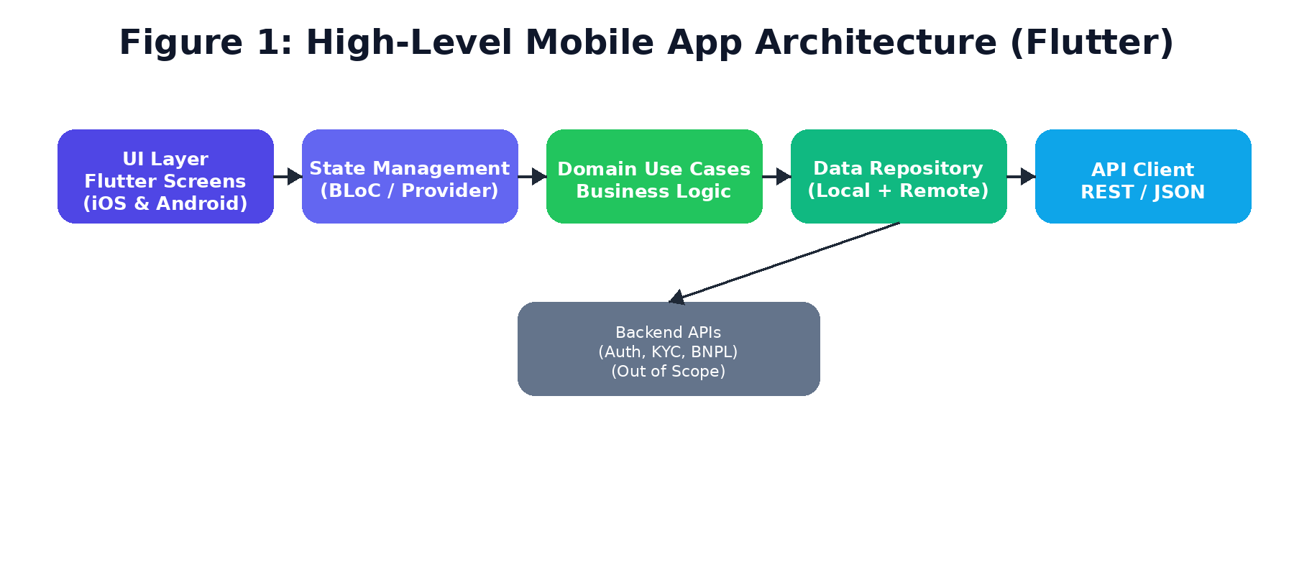

Figure 2: App Navigation Map / User Journey

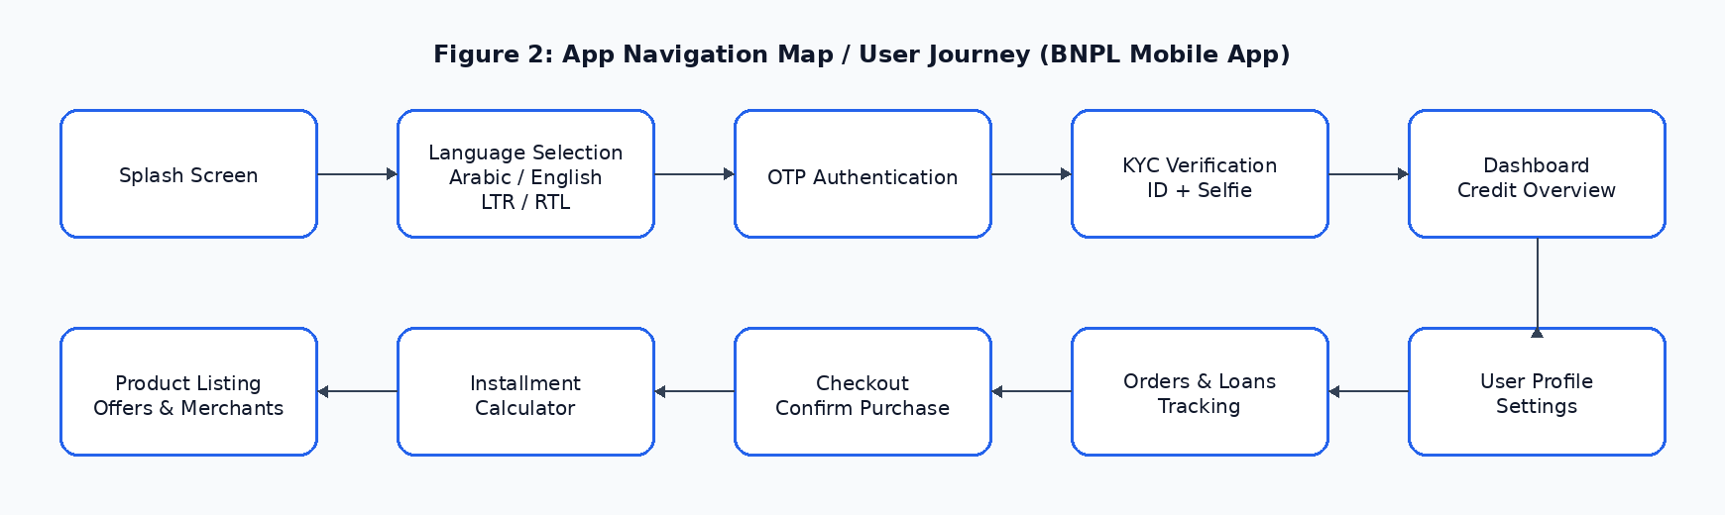Figure 3: Localization & RTL/LTR Strategy

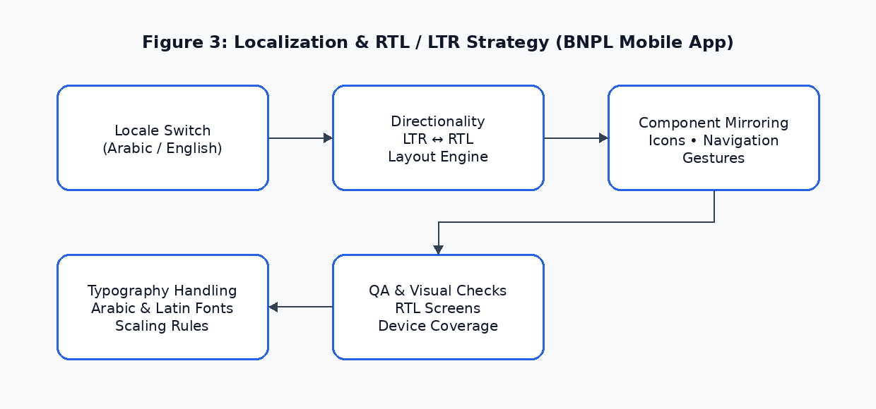

7. Security & Compliance (App-Side)
- Transport security: HTTPS/TLS only; certificate pinning optional if required.
- Token handling: store tokens in secure storage; avoid logging sensitive payloads in production.
- PII handling: minimal local persistence; mask sensitive fields; secure file handling for KYC images.
- Biometrics: OS-level biometric prompts; fallback to OTP/PIN per requirements.

8. Development Methodology
Agile delivery using weekly sprints and continuous QA. Each sprint includes planning, development, code review, QA testing, and a demo. A shared backlog and acceptance criteria will be maintained for transparent progress tracking.
- Sprint planning + backlog grooming (weekly).
- Definition of Done: code reviewed, unit/widget tests where applicable, QA passed, and demo ready.
- QA support: iterative fixes based on client feedback during staging/testing releases.

9. Deliverables
- Flutter source code repository (feature modularized, documented setup).
- Configured localization for Arabic (RTL) and English (LTR).
- Integrated app flows: OTP/biometrics, KYC, dashboard, products, calculator, checkout, orders, loans, profile.
- Release-ready builds for iOS (IPA) and Android (AAB/APK) for testing environments.
- QA test cases and final test report (device matrix + key scenarios).
- Handover package: build/run instructions, environment variables, and release checklist.
- 3 months of complimentary frontend support after delivery (minor bug fixes, basic monitoring guidance, and performance-related frontend issues).

Complimentary Support (3 Months)
- - Bug fixing for minor UI issues and crashes reproducible in supported environments.
- - Basic performance tuning and UI responsiveness improvements.
- - Assistance interpreting frontend logs and issues (requires Client to provide access to crash/analytics tools).
- Note: Feature enhancements, new screens, or changes due to backend/API changes are excluded and treated as change requests.

10. Assumptions & Client Dependencies
- Client will provide finalized UI references/screens, brand assets, and copy (Arabic & English).
- Client will provide API documentation, endpoints, test credentials, and sandbox environments for all required features.
- KYC vendor requirements (image specs, liveness requirements, SDKs) will be shared before implementation.
- App Store / Play Store developer accounts, signing certificates, and provisioning profiles will be managed by the client.
- Actual development time line will be count after getting the approved UI and APIs.

Conclusion
This proposal outlines a clear, focused, and scalable approach to developing a BNPL Mobile Application frontend using Flutter for both iOS and Android platforms. By leveraging a single, high-performance codebase, the solution ensures faster time-to-market, consistent user experience, and long-term maintainability. The scope is intentionally limited to frontend development, enabling the product team to validate the BNPL concept efficiently while supporting critical features such as bilingual (Arabic & English) usage, RTL/LTR layouts, secure authentication, KYC workflows, and seamless loan and order management. With a structured delivery plan, defined milestones, and startup-friendly payment terms, this engagement is well-positioned to support rapid MVP launch and future platform expansion.

Financial Proposal
Cost Estimate (Single Phase)
Pricing model: Fixed price (USD) for the single development phase (frontend only).
Scope Focus | Weeks | Estimated Cost (USD)
BNPL Mobile Application (iOS & Android) – Frontend Development | 6 | $3,000

Payment Terms
- Work will begin after receiving a 30% advance payment. The remaining 70% will be paid against milestone acceptance as per the milestone distribution.
- Any scope changes will be handled through a change request (CR) and may impact cost/timeline.

Remarks
- This estimation assumes standard BNPL flows and one primary KYC verification flow as exposed by the client APIs.
- Payment/collection integration method (redirect, webview, SDK) will be implemented as per the client’s provided approach.
- Push notifications (FCM/APNs) can be included if endpoints and credentials are provided; otherwise treated as optional.
- All timelines are subject to timely availability of APIs, test environments, and client review cycles.

Relevant Project References:
- eCook – https://apps.apple.com/us/app/ecook/id6450396013
- LENTHO – https://apps.apple.com/de/app/lentho-community/id1602655332
- Vimory – https://apps.apple.com/us/app/vimory-slideshow-video-maker/id1359573092
- Worktok- https://riseuplabs.com/worktok/
- Sisimpur – https://play.google.com/store/apps/details?id=apps.orangebd.sisimpur
- BMI Calculator – https://apps.apple.com/us/app/bmi-calculator-weight-monitor/id6475051596
- Augmi – https://play.google.com/store/apps/details?id=com.riseuplabs.augmi
- Islamic Quotes – https://apps.apple.com/us/app/islamic-quotes-motivation/id6448677012

